TECHNICAL REQUIREMENTS

FOR THE

MULTI-OIL LEVEL INDICATOR

AUTOMATION OF THE OLS TEST BENCH

ALLEN AIRCRAFT PRODUCTS, INC.

REPORT #250129

PREPARED BY: Rick Ales, R. Ales Consulting LLC

Name, Title

APPROVED BY:

Name, Title

ALLEN AIRCRAFT PRODUCTS, INC.

RAVENNA, OHIO

Revision History

|  |  |  |  |
| --- | --- | --- | --- |
| **Rev** | **Notes** | **By** | **Date** |
| Draft 1 | Initial Draft | R. Ales | 2024/02/07 |
| Draft 2 | User Case 5: Changed the Test method to more align with current ATP procedure.  5.1.4 Change pump controller to three speed servo. | R Ales | 2024/07/23 |
| Draft 3 | Overhaul to reflect state of the project on 3/1/25 | R. Ales | 2025/03/01 |

Table Of Contents

Paragraph Page

1.0 Introduction 3

1.1 Reference Documents: 3

1.2 Notation 3

1.3 Allen Aircraft Products Agile Project Management Glossary: 3

2.0 MOLI Project Overview: 4

3.0 EPIC 1 4

3.1 Production Tester User Story 5

3.2 Maintenance User Story 5

3.3 Hardware Inputs: 5

3.4 Hardware Outputs: 5

3.5 HMI: 5

3.6 Use Case 1: Load Test Plan -- Maintenance User 6

3.7 Use Case 2: Validate Test System -- Maintenance User 6

3.8 Use Case 3: Read Test Configuration -- Production Test User 7

3.9 Use Case 4: Initialize DUT test -- Production Test User 7

3.10 Use Case 5: Run DUT Test -- Production Test User 7

3.11 Use Case 5: Generate DUT Test Report -- Production Test User 9

4.0 EPIC 2 10

5.0 APPENDIX A NOT PART OF THIS SPECIFICATION 10

1. Introduction

The following document sets forth the requirements of the Multi-Level Oil Indicator (MLOI) program for automating the acceptance testing of oil level sensors. The MLOI program is divided into phases or epics. The first epic is for automating production tests of Allen 8005571.05 (P&WC 30Y0241-01) Oil Level Sensor In particular the Oil Level Test Bench protocol defined in ACCEPTANCE TEST PROCEDURE FOR ALLEN 8005571.05 (aka Elevation OLS ATP).

* 1. Reference Documents:

ACCEPTANCE TEST PROCEDURE FOR ALLEN 8005571.05, Report# 200333

* 1. Notation
* Means Informative
* Means Requirement

LV LabVIEW

AAP Allen Aircraft Products

ATP Acceptance Test Procedure

OLS Oil Level Sensor

DUT Device Under Test

AI Analog Input

XL MS Excel

MLOI Multi-Level Oil Indicator, designation of the automated tester described herein.

SHALL Absolute Requirement

MAY Permissive Requirement

* 1. Allen Aircraft Products Agile Project Management Glossary:

**[Agile:](https://www.atlassian.com/work-management/project-management)**[Project management](https://www.atlassian.com/work-management/project-management) as an iterative approach to delivering a project, which focuses on continuous releases that incorporate customer feedback.

**Epic:** Project as part of a program defined by one or more User Stories.

**User Story:**  Description of the end goal of an Epic from the user’s perspective.

**Use Case:**  Describe the system or user steps of a process to generate testable requirements that can be turned into executable tasks.

**Backlog:** List of tasks derived from Use Cases

**Scrum:**  Sprint meeting to prioritize task execution from the backlog and plan deliverables.

**Sprint:**  Small work cycle or iteration intended to execute Scrum tasks and deliver content.

**Kanban board:**  Planning tool to visualize the work in progress divided into stages, typically Requirements Definition; Design, Develop. Test, Release.

**Standup:** Frequent, brief meeting to address immediate needs to execute the Sprint.

**Sprint review:**  Meeting to approve transition to next Sprint by verifying the completion of Sprint deliverables.  (Developers merge branch into main, Test new main code.)

1. MOLI Project Overview:

The project LV Programming project objectives are divided into phases or Epics that are each suitable for release to production as follows:

* Epic 1 -- Single DUT automated test
* Epic 2 – Multiple Elevate OLS DUT automated Test
* Epic 3+ – MLOI capability extended to accommodate other OLS product lines.

The project hardware including the tank, pump and instrumentation also has two phases as follows:

* HW 1 – Prototype phase where all items are COTS and custom configurations are achieved through breadboards or otherwise temporary connections.
* HW 2 – Production where custom interfaces have been designed and fit for purpose implemented, ie interface unit manufactured as a custom PCB.
* Both the LV application code and HW shall be version controlled.
* Version control follows the Major, Minor convention where the Major revision signified by a letter with Q indicates an evaluation version, and letters beginning with A indicate production released. The minor version is signified by a sequential number indicates the next revision that is form, fit and function compatible with Major production revision.
* Green = to test; Red = Bad or Fault; Yellow ,in simulation mode.
* The system shall have distinct modes, Test and Maintenance.
* The objective is to provide a means to restrict access to modifying the test from the casual operator conducting the test, where Maintenance mode would allow a technician the ability to tune or otherwise calibrate the system.

EPIC 1

EPIC 1 is a fully functional system with the capability to test a single PWC Elevate OLS device (the DUT) over a test cycle described in the following Use Cases.

* The EPIC 1 System MAY be placed into production service with the HW1 (breadboard) hardware.
  1. Production Tester User Story

The Production Operator’s objective is to conduct the test, resulting in a Pass/Fail Acceptance Test Report for the DUT containing the product information and the test status. An overview of the MLOI Test Operator Use case is illustrated here.

The Operator starts the application, selects the test configuration to use; enters the specific test information; loads the single DUT; Runs the Test; then may print the results. The operator may choose to set various levels and read the OLS response to investigate suspect results then decide where to re-run the test or reject the DUT.

* 1. Maintenance User Story

The Maintenance User role is to maintain the apparatus. This may include loading a new test configuration, performing system maintenance like extensive calibration, capabilities studies or system response tuning. Maintenance User may wish to evaluate the application software and the hardware separately. The Maintenance User would also install and update the system components.

* 1. Hardware Inputs:
* ChA and ChB resistance measurement 0-1700Ω +/- 1%
* ChA and ChB Current Source 14.7 mA +/- 0.05%
* Resistance measurement calibration check shall be enforced monthly.
* Level measurement (Process Variable PV) 2.5 to 8.5 inches +/- 0.0005”
* Level measurement calibration check shall be enforced daily
  1. Hardware Outputs:
* Level control (Set Point SP) 2.5 to 8.5 inches +/- 0.002”
* Level control shall be assessment shall be enforced annually.
  1. HMI:
  + Shall provide a one-button means for starting the automated test.
  + Shall provide a means to manually control the Tank Level.
  + Shall display the current ChA and ChB measurement to 0.1Ω
  + Shall display the level measurement to 0.001”
  + Shall provide time-based plot of the resistance for both ChA and ChB, and tank Level.
  + Shall display instrument status.
  + Shall display the Pass/Fail status and progress of the test.
  + Shall provide a menu means to launch secondary methods.
  + Shall not require operator to enter redundant information.
  1. Use Case 1: Load Test Plan -- Maintenance User
* Document management
  + The test plan shall be an XL workbook named to be traceable the test protocol implemented.
  + The test plan shall be version controlled in the Test repository per AAP QUAM.
  + There shall be a means to add/include the test plan path into the user prompt.
* Enter the test bench configuration parameters into XL test plan.
  + The test plan shall contain the configurable test bench parameters as determined by the test bench design.
* Tabular data should be a copy and paste operation from the reference Test Document (ATP) into the XL Test Plan document for loading as a LV parameter.
* Enter DUT specific configuration parameters into XL test plan. Eventually the test plan may include variations of the test protocol that are run at different stages of production. For example, pre-pot test the DUT has no connector, post-Pot is the Actual ATP.
  + The test plan shall contain the referenced test protocol test bench parameters as determined by the test bench design.
  + It should be a copy and paste operation to include the Test bench parameters into the XL Test Plan document.
  + The Test Plan shall contain a template of each test report generated on a separate sheet in the test plan XL workbook.
  + The test plan shall be capable of containing multiple templates to accommodate recording multiple test points or variations of test protocol.
  1. Use Case 2: Validate Test System -- Maintenance User
* Calibration Procedure
  + There shall be a means to perform a 5-point linear calibration on each AI input.
  + There shall be a means to perform a 5-point linear calibration the Level Sensor.
  + These Bench calibrations shall be saved and linked to the Test Plan.
* Troubleshooting Aids
  + There shall be a means for manually setting the tank level.
  + Each instrument (DataQ, Keyence) shall provide a health indictor.
* There shall be a simulate mode that provides simulated instrument input and Level response to be used with debugging.
* There shall be a test vector mode that reads and processes AEPS type test data to validate the system processing algorithm.
  1. Use Case 3: Read Test Configuration -- Production Test User
* LV program must launch from PC desktop ICON in application running mode.
* Maintenance User exclusive controls and Indicators shall be hidden in Test mode.
* All Test Parameters options must be presented in the form of a discrete choice (i.e. dropdown, pick list, radio button etc.).
* Path to valid XL test plans shall be saved in a non-volatile means and presented as a choice by Test name configured by the Maintenance User.
* The system shall be configured, initialized and shall report any NOT READY to test status: i.e. no functional instrument, out of calibration data, error reading test Plan etc.).
  1. Use Case 4: Initialize DUT test -- Production Test User
* Load DUT identification information
* Engineering shall provide an ATP Test report template that provides the reference for the required DUT Test Information.
* There shall be a single dialog box to enter the required DUT test information.
* The DUT information input shall be displayed and request conformation, in the form of an “are you sure?” type prompt with a YES, NO choice response. On NO reply, the user must be able to update that input which shall be retained but editable.
* Load DUT into the test bench.
* On YES reply, the system shall perform a continuity check to indicate ready to test if continuity is detected otherwise indicate not ready for test.
* The test status indicator may provide a tool tip as to the not ready issue.
  1. Use Case 5: Run DUT Test -- Production Test User
* The Test protocol shall implement the ACCEPTANCE TEST PROCEDURE FOR ALLEN 8005571.05, Report# 200333. (attached)
* Figure 2 defines the characteristics of the nominal electrical signal during filling about the 200=300 ohm transition.
* Figure 3 Illustrates the nominal electrical signal step function over the full drain to fill cycle. (bold red curve). The pulses represent the minimum and maximum “set points” referenced in Table 1 & 2 of the ATP. This region is the Switch Zone. In the low areas showing the expected resistance measurement is the R Measurement Zone. The Resistance is monitored in the R Measurement Zone as a diagnostic but not reported as part of the ATP.
* Figure 4 is an expanded view of the Switch Zone for the fill transition from 100Ω to 200Ω. The Target Test Point level is ½ the Target Test Point measurement uncertainty less than the specified Fill Limit. This guarantees the actual measurement level set is less than the maximum specified switch point.

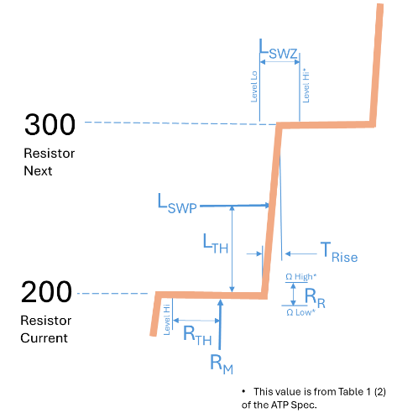

WHERE:

**LSWP**Level Switch Point - The next Level measurement after the Resistance measurement is grater than LTH when Filling.

**LTH**Level Threshold – Average of Resistance Requirement at current level and Resistance Requirement at the next level.

**LSWZ**Level Switch Zone - From Table 1 (2) Range **LSWP** must be between for Level to pass.

**TRise**Rise Time - The time measure between from 110% of Current **RM** to 90% of the Next **RM**

Transition characteristic definitions.

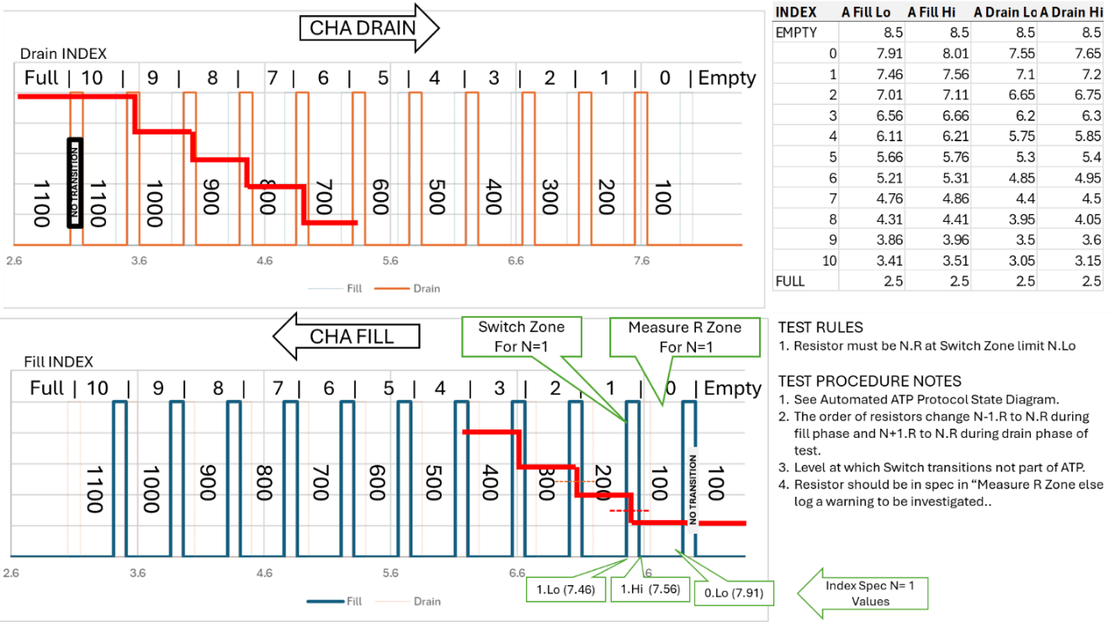

Figure 3 Illustrated Drain-Fill cycle

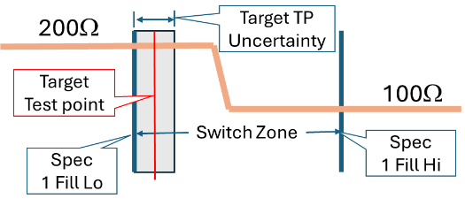

Figure 4 Determination of the Target Test Point

* + The oil level shall be cycled from empty to full to empty prior to testing.
  + The oil level shall be filled from empty to the Target Test Point.
  + The Resistance shall be measured after any level variations subside to the specified criteria.
  + If the measured resistance is within the specified tolerance, the test at this level is PASS, else a FAIL Shall be logged.
  + The above three steps are repeated for each Low Fill Limit alternating between measuring ChA and ChB.
  + The oil level shall be drained from full to the Target Test Point.
  + The Resistance shall be measured after any level variations subside to the specified criteria.
  + If the measured resistance is within the specified tolerance, the test at this level is PASS, else a FAIL Shall be logged.
  + The above Three steps are repeated for each High Drain Limit, alternating between measuring ChA and ChB.
  + The DUT shall be recorded as PASS if no FAILs are recorded.
* The test status shall graphically display Ch A & Ch B resistance in ohms and display the Level in inches.
* All three traces shall be scaled so they are presented overlayed at a similar size. The Chart scale is configurable test parameter.
* A display shall indicate each Switch status as NOT TESTED (gray), PASS (green) or FAIL (red) or ERROR (yellow) for a detected procedural problem.
* A display shall indicate the measured Target Test Point and the actual resistance measured there.
* The User must have the means to monitor the Test bench health during testing.
* Users must have a means to PAUSE the test.
* Users must have a means to ABORT the test.
* Users must have the option to RERUN the test.
* Users must have the option to run the level in manual or automatic modes.
* The default test mode is automatic.
  1. Use Case 5: Generate DUT Test Report -- Production Test User
* The Test results and the Product information for each test shall be saved in one XL workbook at the option of the operator.
* The ATP Test Report shall be on one sheet labeled “ATP Report” as specified in the Report Template supplied by Engineering.
* The time in 50ms intervals, ChA and ChB resistance in ohms and Level in inches shall be recorded and plotted on a sheet labeled “Raw Data.”
* The third sheet shall be labeled “Analysis” and include the actual level at which the Switch Point occurred (**LSWP** refer to figure 2).
* The sheet labeled “Analysis” shall include identification of “double actuations” (definition TBD) and slow “rise time” (definition TBD).
* The values on the Analysis sheet may be calculated post-test execution.

EPIC 2

EPIC 2 adds the capability to test multiple PWC Elevate OLD DUT. . Many of the EPIC 1 requirements will have to be adjusted to accommodate multiple sensor test scenario.

* The EPIC 2 System Shall be placed into production service with the HW2 only.

1. APPENDIX A NOT PART OF THIS SPECIFICATION

Miscellaneous Information

* The sheet shall be named the variation of the test concatenated DUT_ID
* The sheet shall be derived from the template contained in the XL test plan for the appropriate variant of the test.
* The XL Test Plan shall contain a test log of
* User must acknowledge/approve saving acquired data to Test Report.
* The path of the test report repository shall be configured by the Maintenance user.
* The user cannot change the test report or the test repository path.
* The user shall be prompted for any additional closing notes or annotations to be included.
* The first Sheet of the test report shall include Job number as Title, PRE and POST test annotations input by the user and the actual test bench configuration values for the test run.
* Each DUT test report sheet shall contain tables for each switch of:
  + Ch A Fill: in Range? Pass/Fail; Level Value of actuation.
  + Ch B Fill: in Range? Pass/Fail; Level Value of actuation.
  + Ch A Drain: in Range? Pass/Fail; Level Value of actuation.
  + Ch B Drain: in Range? Pass/Fail; Level Value of actuation.
* Each DUT test report sheet shall contain Graph of Ch A Ch B and Level over the whole test.
* Do we want to keep a test log, perhaps as a sheet in the Test Plan that list the Job Number and general Pass/fail status?

Proposed Elevation OLS Test Bench Control Hardware

Front panel concept

XXXX